**Accounting and Financial Reporting**

**Extra Applications_Lecture Week 4**

***Multiple-Choice Questions:***

1. The accounting process begins with:   
A. Analysis of business transactions and source documents.  
B. Preparing financial statements and other reports.  
C. Summarizing the recorded effect of business transactions.  
D. Presentation of financial information to decision-makers.  
E. Preparation of the trial balance.

2. An account used to record the owner's investments in the business is called a(n):   
A. Withdrawals account.  
B. Capital account.  
C. Revenue account.  
D. Expense account.  
E. Liability account.

3. A formal promise to pay (in the form of a promissory note) a future amount is a(n):   
A. Unearned revenue.  
B. Prepaid expense.  
C. Credit account.  
D. Note payable.  
E. Account receivable.

4. A credit is used to record:   
A. An increase in an expense account.  
B. A decrease in an asset account.  
C. A decrease in an unearned revenue account.  
D. A decrease in a revenue account.  
E. A decrease in a capital account.

5. Of the following accounts, the one that normally has a credit balance is:   
A. Cash.  
B. Office Equipment.  
C. Wages Payable.  
D. Owner, Withdrawals.  
E. Sales Salaries Expense.

6. Cool Tours had beginning equity of $72,000; revenues of $90,000, expenses of $65,000, and withdrawals by owners of $9,000. Calculate the ending equity.   
A. $88,000.  
B. $25,000.  
C. $97,000.  
D. $38,000.  
E. $47,000.

7. Della's Donuts had cash inflows from operating activities of $27,000; cash outflows from investing activities of $22,000, and cash outflows from financing activities of $12,000. Calculate the net increase or decrease in cash.   
A. $61,000 increase.  
B. $37,000 increase.  
C. $7,000 decrease.  
D. $7,000 increase.  
E. $34,000 decrease.

8. Rent expense that is paid with cash appears on which of the following statements?   
A. Balance sheet.  
B. Income statement.  
C. Statement of owner's equity.  
D. Income statement and statement of cash flows.  
E. Statement of cash flows only.

9. A company borrows $125,000 from the Eastside Bank and receives the loan proceeds in cash. This represents a(n):   
A. Revenue activity.  
B. Operating activity.  
C. Expense activity.  
D. Investing activity.  
E. Financing activity.

10. Use the following information as of December 31 to determine equity.  
 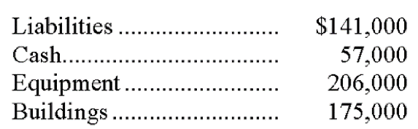    
A. $57,000.  
B. $141,000.  
C. $297,000.  
D. $438,000.

***Matching***

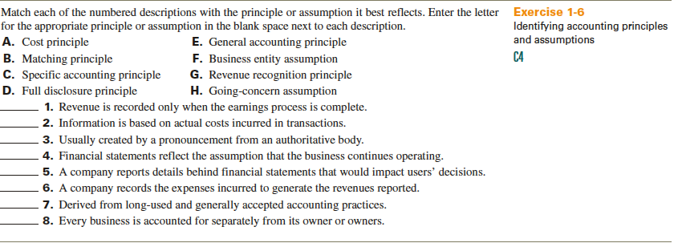

***Preparing Financial Statements***



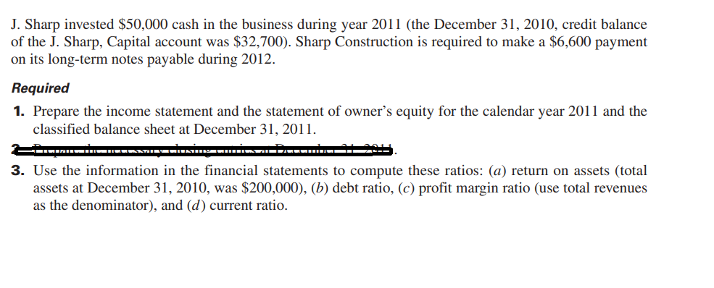

Answers

***MCQs***

1. The accounting process begins with:   
**A. Analysis of business transactions and source documents.**B. Preparing financial statements and other reports.  
C. Summarizing the recorded effect of business transactions.  
D. Presentation of financial information to decision-makers.  
E. Preparation of the trial balance.

2. An account used to record the owner's investments in the business is called a(n):   
A. Withdrawals account.  
**B. Capital account.**C. Revenue account.  
D. Expense account.  
E. Liability account.

3. A formal promise to pay (in the form of a promissory note) a future amount is a(n):   
A. Unearned revenue.  
B. Prepaid expense.  
C. Credit account.  
**D. Note payable.**E. Account receivable.

4. A credit is used to record:   
A. An increase in an expense account.  
**B. A decrease in an asset account.**C. A decrease in an unearned revenue account.  
D. A decrease in a revenue account.  
E. A decrease in a capital account.

5. Of the following accounts, the one that normally has a credit balance is:   
A. Cash.  
B. Office Equipment.  
**C. Wages Payable.**D. Owner, Withdrawals.  
E. Sales Salaries Expense.

6. Cool Tours had beginning equity of $72,000; revenues of $90,000, expenses of $65,000, and withdrawals by owners of $9,000. Calculate the ending equity.   
**A. $88,000.**B. $25,000.  
C. $97,000.  
D. $38,000.  
E. $47,000.

7. Della's Donuts had cash inflows from operating activities of $27,000; cash outflows from investing activities of $22,000, and cash outflows from financing activities of $12,000. Calculate the net increase or decrease in cash.   
A. $61,000 increase.  
B. $37,000 increase.  
**C. $7,000 decrease.**D. $7,000 increase.  
E. $34,000 decrease.

8. Rent expense that is paid with cash appears on which of the following statements?   
A. Balance sheet.  
B. Income statement.  
C. Statement of owner's equity.  
**D. Income statement and statement of cash flows.**E. Statement of cash flows only.

9. A company borrows $125,000 from the Eastside Bank and receives the loan proceeds in cash. This represents a(n):   
A. Revenue activity.  
B. Operating activity.  
C. Expense activity.  
D. Investing activity.  
**E. Financing activity.**

10. Use the following information as of December 31 to determine equity.  
 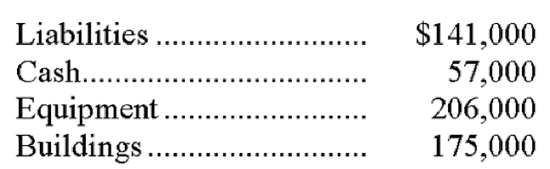    
A. $57,000.  
B. $141,000.  
**C. $297,000.**D. $438,000.  
E. $579,000.

|  |  |  |  |  |
| --- | --- | --- | --- | --- |
| Code |  | Description | Principle or Assumption | |
| G | 1. | Revenue is recorded only when the earnings process is complete. | Revenue recognition principle |
| A | 2. | Information is based on actual costs incurred in transactions. | Cost principle |
| C | 3. | Usually created by a pronouncement from an authoritative body. | Specific accounting principle |
| H | 4. | Financial statements reflect the assumption that the business continues operating. | Going-concern assumption |
| D | 5. | A company reports details behind financial statements that would impact users' decisions. | Full disclosure principle |
| B | 6. | A company records the expenses incurred to generate the revenues reported. | Matching (expense recognition) principle |
| E | 7. | Derived from long-used and generally accepted accounting practices. | General accounting principle |
| F | 8. | Every business is accounted for separately from its owner or owners. | Business entity assumption` |

Part 1

SHARP CONSTRUCTION

Income Statement

For Year Ended December 31, 2011

Revenues

Professional fees earned $96,000

Rent earned 13,000

Dividends earned 1,900

Interest earned 1,000

Total revenues $111,900

Expenses

Depreciation expense—Building 10,000

Depreciation expense—Equipment 5,000

Wages expense 31,000

Interest expense 4,100

Insurance expense 9,000

Rent expense 12,400

Supplies expense 6,400

Postage expense 3,200

Property taxes expense 4,000

Repairs expense 7,900

Telephone expense 2,200

Utilities expense 3,600

Total expenses 98,800

Net income $ 13,100

SHARP CONSTRUCTION

Statement of Owner's Equity

For Year Ended December 31, 2011

J. Sharp, Capital, December 31, 2010 $32,700

Add: Investments by owner $50,000

Net income 13,100 63,100

95,800

Less: Withdrawals by owner (12,000)

J. Sharp, Capital, December 31, 2011 $83,800

Problem 4-4A *(Continued)*

SHARP CONSTRUCTION

Balance Sheet

December 31, 2011

*Assets*

Current assets

Cash $ 4,000

Short-term investments 22,000

Supplies 7,100

Prepaid insurance 6,000

Total current assets $ 39,100

Plant assets

Equipment 39,000

Accumulated depreciation—Equipment (20,000) 19,000

Building 130,000

Accumulated depreciation—Building (55,000) 75,000

Land 45,000

Total plant assets 139,000

Total assets $178,100

*Liabilities*

Current liabilities

Accounts payable $ 15,500

Interest payable 1,500

Rent payable 2,500

Wages payable 1,500

Property taxes payable 800

Unearned professional fees 6,500

Current portion of long-term note payable …... 6,600

Total current liabilities $ 34,900

Long-term liabilities

Long-term notes payable* 59,400

Total liabilities 94,300

*Equity*

J. Sharp, Capital 83,800

Total liabilities and equity $178,100

* $66,000-$6,600